

DEPARTMENT OF COMPUTER SCIENCE AND ENGINEERING

CSA05-DATABASE MANAGEMENT SYSTEMS LAB MANUAL
DDL Commands – CREATE, ALTER, DROP

AIM:
To Create, Alter, Drop, Rename, Truncate using Data Definition Language (DDL) statements.

Description:
Data Definition Language (DDL) statements are used to define the database structure or schema.
DDL Commands: Create, Alter, Drop, Rename, Truncate
- CREATE - to create objects in the database
- ALTER - alters the structure of the database
- DROP - delete objects from the database
- TRUNCATE - remove all records from a table, including all spaces allocated for the records are removed
- RENAME - rename an object

SYNTAX: CREATE TABLE
CREATE TABLE table_name (
column_name1 data_type, column_name2 data_type, column_name3 data_type,
....
);

ALTER A TABLE
To add a column in a table ALTER TABLE table_name ADD column_namedatatype;

To delete a column in a table

ALTER TABLE table_name DROP COLUMN column_name;

DROP TABLE
DROP TABLE table_name;

TRUNCATE TABLE
TRUNCATE TABLE table_name;

Questions:
- Create a table name EMPLOYEE with following structure.

# | Column Name | Description | Data Type
1 | Emp ID | Employee ID | INT
2 | Emp NAME | Employee Name | VARCHAR (30)
3 | Phone No | Employee phone number | BIGINT
4 | Department | Employee Department | VARCHAR (30)
5 | Account NO | Employee Account No | BIGINT

Create a table name DEPARTMENT with following structure.

# | Column  Name | Description | Data Type
1 | DeptID | Department ID | INT
2 | DeptName | Department Name | VARCHAR(30)
3 | DeptHead | Department Head | VARCHAR(30)

Delete the Salary column from the EMPLOYEE table.

4.)Rename the EMPLOYEE table as EMPLOYEEDETAILS

OUTPUTS:
1) 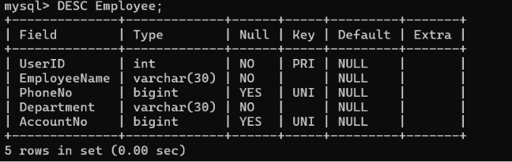

2) 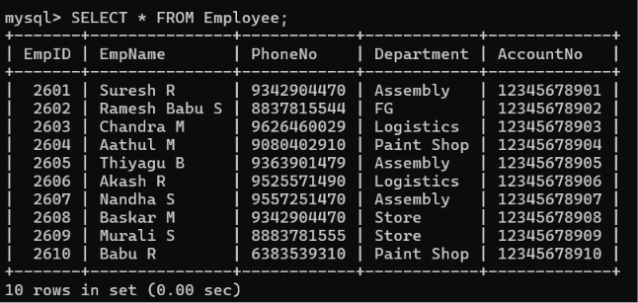

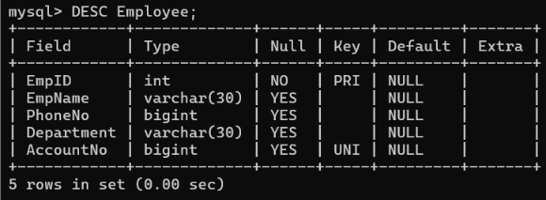

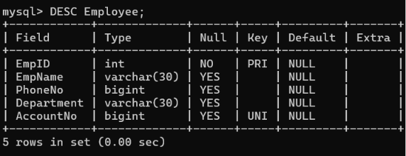

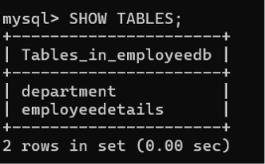

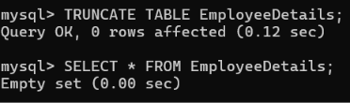

RESULT:
Tables are created, altered and modified using DDL commands.

